The Representational Costs of Candidate Residency Requirements

Wordcount: 8,953
Keywords: political geography, representation, redistricting, campaigns and elections, election law, place identity

Abstract

Most American political jurisdictions require geographic residency within or near that jurisdiction, sometimes for years prior to candidacy. These requirements have received little scholarly attention beyond the legal field. It is assumed that residency requirements facilitate higher-quality representation. In this paper, however, I reconsider the potential negative consequences to representation posed by candidate residency requirements. Specifically, I find that legislators in states with more stringent requirements face far less political competition due to a smaller pool of potential challengers, potentially diminishing their level of responsiveness and democratic accountability. Districts in these states are also more significantly gerrymandered, likely to take into account incumbents’ residencies. All told, these often-ignored legal frameworks have enormous consequences for elections and representations at multiple levels of American government.

The legal requirement that most elected officials in the United States establish and maintain residency in the jurisdiction they represent is largely taken for granted in the modern era. Consequently, it has been all but ignored by the political science literature, or else treated as an unalterable and self-evident truth of American political representation. Residency requirements for political candidates have not been sufficiently critiqued nor defended with either theoretical or empirical evidence on either side. Nor have their philosophical merits and consequences been properly considered in today’s highly partisan, geographically mobile, and politically nationalized era.
These are the gaps this paper aims to close. In the analysis that follows, I reengage with the previous literature on candidate residency requirements, nearly all of which is from the legal field, and little to none of which is empirically based. I also consider residency requirements in light of recent political science findings around emerging concepts like place identity, local candidate roots, and political geography generally. In doing so, I first articulate a comprehensive defense of the background, stated rationales, and demonstrable benefits of requiring local candidate residency in the modern era. Previous work has shown that elected officials with deeper place-based roots and longer residencies in the areas they represent are viewed as more trustworthy and legitimate representatives than those commonly derided as “carpetbaggers.” (Munis 2021; Hunt 2022; Hunt and Fontana 2023) We have also seen evidence that more geographically rooted representatives are more bipartisan (Kaslovsky and Crosson 2023) and less ideologically extreme (Hunt and Rouse 2023) than their carpetbagging counterparts.
Next, however, I leverage new theoretical arguments and empirical evidence that call into question the wisdom of strict residency requirements. Among other concerns, the electoral safety afforded to deeply-rooted representatives may come at the cost of healthy electoral competition for their constituency. I show, for example, that states with more stringent residency requirements produce legislators who run without opposition at significantly higher rates. I use data from the American Community Survey combined with original data on sitting state legislators as of 2018 to demonstrate that this is in part a result of a significantly diminished candidate pool in these states and districts. States vary by both the stringency of their residency requirements, and their levels of in-migration. As a result, I estimate that the proportion of a state’s residents who are disqualified for state legislative office by these laws ranges most conservatively from 2-6% of the population on the low end, up to 15-20% on the higher end. Put differently, as much as a fifth of some states’ residents are eligible to vote and required to pay taxes in that state, but are barred from candidacy for state legislature. Even higher proportions of some states’ populations are ineligible for statewide offices like governor.
It may well be that candidate residency requirements remain a crucial component of America’s efforts to produce high-quality political representation. Recent work has shown that they produce the representatives most likely to stem the tide of polarization and its corrosive effects on our democracy, and that they strengthen the connective tissue of trust between representatives and constituents. But lawmakers or constitutional assemblies aiming to revise these requirements in either direction should be aware of the full scope of potential threats that additional requirements pose to healthy political competition and pluralism, particularly during a time of peak polarization.

Legal and Political Background
In late November of 2021, Dr. Mehmet Oz filed for candidacy as a Republican for the open U.S. Senate seat in Pennsylvania. In doing so, he listed a property he had purchased just weeks earlier located in, as his filing form lists, “Huntington Valley, PA.” Unfortunately for Dr. Oz, there is no Huntington Valley, Pennsylvania—only “Huntingdon Valley” (Lahut 2022). Oz’s campaign quickly corrected the error once the press caught wind of it, but it served as just another piece of evidence for Oz’s “carpetbagger” status; meaning, he was running for Congress in a state to which he was a newcomer, having lived in New Jersey for most of his life (or, as Oz described it on the campaign trail, the “Greater Philadelphia area”). This geographic disparity and the many place-based scandals that ensued may well have sealed Oz’s fate leading up to his November 2022 loss to then-Lt. Governor John Fetterman (D), who himself had much deeper personal connections to the state.
Although he lived full time in New Jersey before and during his candidacy, Oz listed this Pennsylvania address in his candidate filing for a reason. Despite the politically unfortunate misspelling, Oz was adhering to a stipulation in the U.S. Constitution requiring that members of Congress (both House and Senate) “be an Inhabitant of that State for which [s]he shall be chosen” by the time they are elected. Whatever the faults or missteps of his campaign on the carpetbagging issue, and however bruising Fetterman’s attacks on the issue ended up being in the race, Oz was fully complying with the Constitution, which required only that he be an inhabitant “when elected.”
Candidates for state-level offices nearly always face stricter “durational” requirements of residency, meaning that they must live in the state or district (depending on the office) for a specified period of time prior to their candidacy or eventual officeholding. At their most stringent, state laws and constitutions require up to ten years of prior state residency for statewide office, or up to two years of residency within a district for state legislative office. Durational or not, because legal requirements for state offices vary so widely—and thus allow for comparative analysis—they will be the main units of analysis in this paper. More specifically, in order to draw out more granular differences between candidates and districts based on these requirements, the bulk of the empirical analysis to follow is at the state legislative level.
In order to ascertain the strictness of each state’s candidacy residency requirement for state legislatures, I collected summary data on each state’s residency requirement for candidates from the National Conference of State Legislatures (NCSL). I combined this data with direct inspection of state law and constitutions where questions about the specificity of state law remained ambiguous by NCSL’s standards. Because many states have divergent restrictions in this area, analysis will be made significantly simpler by binning states into broader categories based on these restrictions. Although many states restrict candidacy for state legislature based on length of residency in the state, they also restrict it based on residency inside the state legislative district itself (see Appendix Table A1). I base these categories on the latter restriction, both because there is more variation on this measure and because it is much closer geographically to the kinds of considerations potential candidates are making when running for state legislature. These ordinal categories are displayed in the map in Figure 1. States vary from Connecticut and Florida, which don’t require candidates to live in the district until the day they take office, to Mississippi and Illinois, which require residency in the district for two full years prior to candidacy for state legislature.
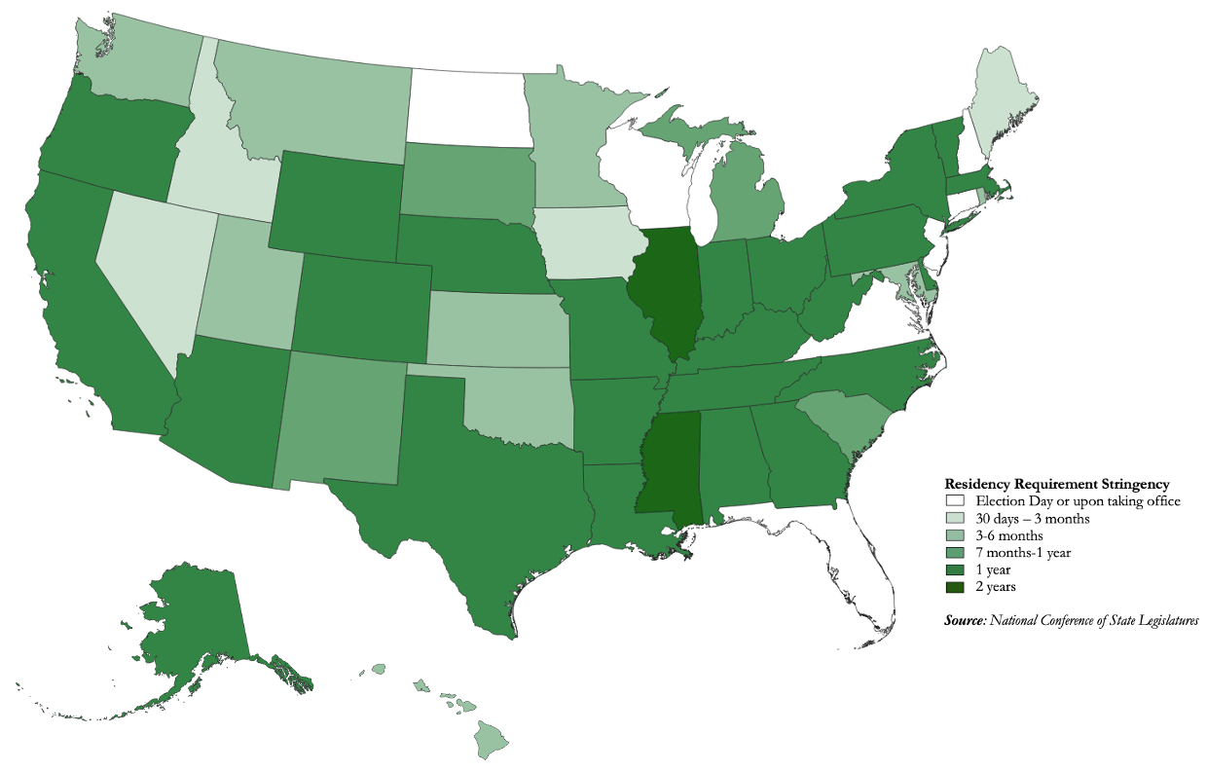
Figure 1: Map of American states based on stringency of their state legislative residency requirement. Denotes the amount of time prior to candidacy in which each state requires a candidate to have lived within the boundaries of the district they are running in.

Rationale and Arguments in Favor
The political jeopardy the Oz candidacy found itself in was a manifestation of the reasons Americans generally seem to support residency requirements for candidates for office. It also reflects the ongoing rationale for these laws and constitutional requirements, including the representational advantages associated with having elected leaders with deep roots in the area they represent. Compared to his opponent, Oz was viewed as an outsider because his principal life experience was from a neighboring state rather than Pennsylvania. Voters, as a result, saw him as (among other things) out of touch with his future constituents. But the representational drawbacks to “carpetbagging”—and thus, the benefits associated with residency requirements—go well beyond political optics.
Many of these arguments originate with the founding of the nation. It could be argued, for example, that much of the impetus for the Revolution that resulted in American independence from the British empire was literal displacement: a people who were governed not by those who lived where they lived and experienced what they experienced, but rather by those an ocean away who did not necessarily have their best interests at heart. Among the many grievances laid out in the Declaration of Independence is the accusation that King George III had “called together legislative bodies at places unusual, uncomfortable, and distant” geographically from the governed.
James Madison’s meticulous notes on the proceedings of the Constitutional Convention offer a window into some of the arguments advanced by some framers of the constitution in favor of establishing not the simple “inhabitancy by election day” requirement that the constitution ended up with, but rather a durational residency requirement of the sort that we see in the states for state-level offices. The most stringent proposed residency requirement—seven full years prior to officeholding—came from John Rutledge of South Carolina. Rutledge’s remarks on the subject capture one of the most common, and commonsense, justifications for requiring long-term residency for candidates for office: “An emigrant from New England to South Carolina or Georgia,” Rutledge argued, “would know little of its affairs, and could not be supposed to acquire a thorough knowledge in less time” than his proposed seven years of residency (Madison 1787). Either Madison or Alexander Hamilton leveraged similar logic in defense of the eventual Constitution in The Federalist #57: that representatives in the Congress “will not only bring with them a considerable knowledge of its laws, and a local knowledge of their respective districts.” (Madison or Hamilton 1789) Put differently, candidate residency in a particular area increased the likelihood that they would be able to identify important constituent concerns that may differ from the concerns of other geographical areas. This condition could be achieved by requiring extensive local residency prior to officeholding.
Other delegates to the Convention voiced darker versions of these arguments, insisting that failing to require residence could result in rampant corruption and misrepresentation of the states. Though the term was not yet in vogue (it would not originate until the Reconstruction Era), the framers were eminently worried about the potential influence of carpetbaggers, both at home and abroad. George Mason of Virginia, for example, warned against “rich men of neighbouring States, [who] may employ with success the means of corruption in some particular district and thereby get into the public Councils after having failed in their own State.” Delegates supportive of strict residency requirements also worried not just about carpetbaggers from other states, but those from other countries. If the Convention failed to require lengthy durational requirements, Mason warned, then “a rich foreign Nation, for example Great Britain, might send over her tools who might bribe their way into the Legislature for insidious purposes.”
Indeed, Madison reports that some proponents felt that even durational requirements as long as three years were “not enough for ensuring that local knowledge which ought to be possessed by the Representative.” But these durational requirements did not garner enough support at the Convention; as it stands, the Constitution requires only that a member of Congress establish state “inhabitancy” by the time they are elected. This has not prevented potential members from testing this rule to the limit, resulting in a number of legal conflicts across American history that elucidate other arguments in favor of these requirements. For example, one such challenge in 1926 questioned whether a member-elect from Pennsylvania was truly an “inhabitant” of the state. The House Committee on Elections ruled that despite the recency and infrequency of the member-elect’s residency in Pennsylvania, the fact that he had both paid taxes and recently voted in the state sufficiently satisfied the framers’ definition of inhabitancy. The majority of the committee argued that the framers intended that a representative in Congress “must have openly and avowedly by act and word subjected himself to the duties and responsibilities of a member of the body politic of the particular State,” (Cannon’s Precedents, pp. 339-340) which the member-elect had done. In other words, the very least we can expect from someone seeking to represent a certain area is to be an active citizen and civic participant in of that place themselves (Maskell 2015).
There is also ample evidence that the American public is supportive of residency requirements as an enforcement mechanism for quality representation. This is reflected in the similar requirements placed on voters: that they be a resident of a place for a particular amount of time before being allowed to vote as a citizen of that place. Rosenberg and Wejryd (2022), for example, find that Americans see long-term geographic residency as one of the most preferred and legitimizing attributes of other voters; likewise, they find that Americans are most willing to deny the franchise to those who have not lived in the U.S. for a sufficient amount of time.
Despite the similarity of these requirement types, Americans have very different views of political candidates, and of their fellow voters. Measuring the impacts of candidate residency requirements has traditionally been difficult, particularly given that the previously-discussed congressional requirement in the Constitution does not vary across either time or place. State laws in this area also tend not to change over time. Thus, the most effective way thus far that political scientists have been able to gauge the potential representational benefits of residency requirements is by comparing the quality of electeds who are longtime residents of the jurisdiction they represent, versus those who, like Dr. Oz, are more recent arrivals. For example, the “friends and neighbors” effect pioneered by V.O. Key (1949), in which candidates pull in more electoral support from their most geographically proximate constituencies, has been replicated across multiple time frames and office types (Tatalovich 1975; Bowler, Donovan, and Snipp 1993; Gimpel et al. 2008; Meredith 2013; Johnston et al. 2016; Hunt 2022b). Others have cited broader electoral rewards that voters offer to candidates with deep roots in narrower jurisdictions. Recent work by Hunt, for example, has found that members of Congress with deep local roots electorally outperform their less-rooted counterparts among their own party’s voters in primaries (2021b) and general elections (2021a).
These geographical ties also provide boosts in the extents to which constituents say they trust, relate to, or have favorable opinions of potential candidates for office (Hunt and Fontana 2023). In Figure 2, I replicate Hunt’s findings using pooled data (2006-2020) from the Cooperative Congressional Election Study (CCES) that matches Hunt’s Local Roots Index data with congressional districts in which respondents to the study reside. I find that average job approval ratings of more deeply-rooted members of Congress are consistently higher than those with little or no such roots.

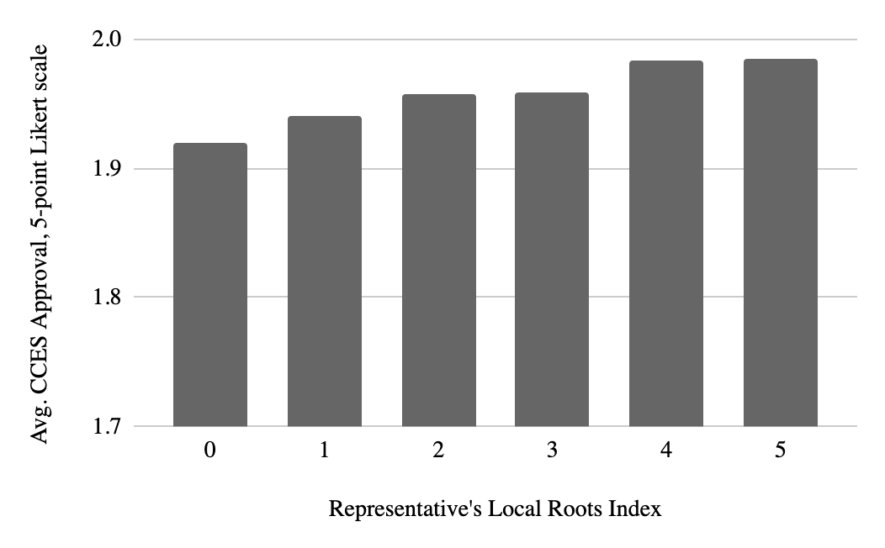

Figure 2: Average approval ratings of members of the U.S. House via respondents to the 2006-2021 CCES (N=547,226), based on the member’s score on Hunt’s (2022) Local Roots Index.

What are the mechanisms behind these representational preferences? Why do voters prefer local representatives? One possibility is the sense of descriptive representation that local ties offer. Scholars have discussed at length both the practical and symbolic benefits that accrue when representatives share descriptive traits with their constituents. These linkages breed trust, identification, and faith that the representative has constituents’ best interests at heart because they are “one of them” (Fenno 1978; Mansbridge 1999; Gay 2002; Banducci, Donovan, and Karp 2004). These observations have largely been reserved for descriptive representation in the areas of race, gender, and personal experience. Descriptive “place” representation is an important addition to this list (Childs and Cowley 2011; Campbell et al. 2019). If a candidate for office has lived in a particular area for a long time prior to running, their personal identification with that place is something they have in common with the voters who live there; indeed, it is the only thing they have in common with every single constituent in the jurisdiction. More materially, voters are more likely to have developed close personal ties with (or at least seen or heard from) their future representative, or to convey their concerns to the candidate so he or she can act upon them.
Other recent evidence from the local roots literature, mainly in the experimental realm, offers other compelling frameworks. Most notable is the emerging concept of “place identity” pioneered in the political arena by Munis (2021) and others (Cramer 2016; Schulte-Cloos and Bauer 2021). In this framework, the place where one resides comprises a meaningful identity that helps define a person’s self-conception (e.g., “I think of myself as a Texan, and this is important to who I am”). As a result, it also helps define voters’ political identities: for example, place identity has been demonstrated to have meaningful effects in campaign messaging (Jacobs and Munis 2018), candidate evaluation (Sajuria and Collignon 2018; Munis 2021), and place-based resentments (Cramer 2016). This identity is particularly crucial given how central a role that place and geographic boundaries play in the American system of political representation, including the persistence of residency requirements.
These representational connections, coupled with the practical electoral advantages demonstrated by previous work, have led to new evidence that more deeply-rooted representatives moderate and localize their behavior in ways that have normative benefits for representation and democracy. For example, they raise and spend more local campaign funds than others, and communicate with their constituents using less partisan, and more policy-focused, styles (Hunt 2022a). Other work has uncovered evidence that the appeal of deep place-based roots are strongest among opposite-party voters, suggesting a cross-cutting representation that could reduce political polarization (Hunt and Fontana 2023). Work from Kaslovsky and Crosson (2023) and Hunt and Rouse (2023) bears out this theory, both uncovering more bipartisan and less ideologically extreme legislative behaviors for more deeply-rooted members of Congress and state legislatures respectively.
What does this mean for residency requirements? If it is indeed the case, as it appears to be, that the representative-constituent relationship is strengthened, viewed as more legitimate, and productive towards the end of bipartisanship and reducing polarization, it stands to reason that requiring residency (and particularly durational residency) of candidates for office is a legal mechanism by which these ends can be achieved. These modern political science findings (including the novel findings in Figure 2) confirm what the framers of the Constitution suspected: that closer-knit, homegrown place linkages between voters and their elected leaders is essential to quality representation, particularly in a geographically vast republic like ours. Insisting on some standard of local ties on the part of our candidates thus may play an important role in bringing about this brand of representation. These findings also have very tangible implications for the quality of political campaigns. In addition to broad, symbolic representational linkages, residency requirements offer to voters “a period in which they may become familiar with the character, habits and reputation of candidates for political office,” and thus be better-prepared to properly evaluate them via the electoral process (Gilbert v. State of Alaska 1974).

Costs & Consequences
It has been well-demonstrated that voters prefer representatives with deeper place-based roots in their jurisdictions. The mechanisms behind these preferences have also been well-theorized by constitutional framers and modern legal and political scholars alike. Local ties may therefore be a highly desirable trait for political candidates on balance.
However, no known works of political science have properly considered the potential costs and negative consequences of candidate residency requirements designed to enforce some presence of these geographic roots. Here, I will first offer a set of normative arguments based in the representation literature to call into question whether geography should feature quite so prominently in requirements for office. I then detail smaller but still crucial logistical concerns around state legislative representation and redistricting. Finally, I turn to an empirical treatment of perhaps the most tangible consequences of residency requirements: the significant narrowing of the candidacy pool, and the blow it may deal to healthy electoral competition.

Normative Arguments
As with the normative arguments in favor of a residency requirement, many of the arguments against it were laid out in detail at the Constitutional Convention. Many of these were logistical (though no less important) concerns about who would be included and excluded by durational requirements. John F. Mercer of Maryland, for example, argued that such a requirement “would certainly exclude men, who had once been inhabitants, and returning from residence elsewhere to resettle in their original State,” even though these candidates would certainly have the “necessary [local] knowledge” to adequately represent those constituents. Madison himself was among the most vocal opponents of proposals to extend the residency requirement to as long as 3 or even 7 years. In addition to logistical concerns around finding long-term residents to represent new Western states, and the potential exclusion of “persons absent occasionally for a considerable time on public or private business,” Madison worried that voters “would often prefer a resident within the County or State, to a candidate of superior merit residing out of it.” In other words, voters might sacrifice more general merits and qualifications in favor of a local resident, thus letting nativism get in the way of electing the most qualified individual possible. Hugh Williamson of North Carolina took Madison’s argument a step further, positing that “new residents” may even be preferable to deeply-rooted ones: “If elected,” he argued, these new arrivals “will be most zealous to Conform to the will of their constituents, as their conduct will be watched with a more jealous eye.”
Others, like George Read of Delaware, worried that strict durational residency requirements would place far too much emphasis and importance on local areas and place-based or regional divisions, and inflame factionalism between Americans. Particularly after the Revolution (although surely the argument holds today given other sorts of divisions and polarization America finds itself contending with), it was crucial that different parts of the country were united under the same cause, and should endeavor to form a national identity that would bind them together in commonality. In responding to a proponent of durational requirements during a debate, Read “reminded him that we were now forming a Natil. Govt. and such a regulation would correspond little with the idea that we were one people.”
Quality political representation is difficult to measure, in part because Americans have a highly diverse set of opinions as to what aspects of representation should be prioritized when choosing a candidate to represent them. Many scholars have touted the benefits, both tangible and symbolic, of descriptive representation (Mansbridge 1999; Gay 2002; Childs and Cowley 2011; English, Pearson, and Strolovitch 2018), and the previous section’s discussion of local candidate roots make clear that residency requirements may help facilitate quality descriptive representation in the area of geography and place. This is particularly true as it relates to dyadic representation between a member of a legislature and the constituents of their particular district.
However, as political competition in states and districts decreases and political nationalization increases (D. A. Hopkins 2017; D. J. Hopkins 2018; Moskowitz 2021; Amlani and Algara 2021), more Americans seem to be turning to surrogate representation on a national level, identifying with out-of-area politicians whose appeal is linked almost uniformly to their alignment with individuals based on partisan or ideological grounds (English, Pearson, and Strolovitch 2018). This has led many to entertain arguments rooted in political realism as to whether the U.S. should consider transitioning away from geography based elections and representation, and rather towards a more nationwide proportional system based on parties and partisanship (Monroe 1995; Blais, Dobrzynska, and Indridason 2005; Iglesias 2017). After all, although the effects of local candidate roots are demonstrable and meaningful, they are modest compared to that of party alignment and identification. Should the latter really be sacrificed in favor of the former?
This leads to another difficult but important question we must consider: If the benefit of residency requirements is a fulfillment of a representational good, why is it privileged over others? Aside from most American legislatures’ age requirements (which, wise or not, are clearly in place to facilitate legislative competency rather than fidelity of representation to a particular age group), no other meaningful representational bond—be it racial, partisan, occupational, or something else—is traditionally included among legal requirements for political candidacy. Indeed, enforcing bonds like these—for example, legally requiring a majority-Black congressional district to accept candidacies only from Black constituents—would almost certainly be unconstitutional, or in all likelihood derided as a racial quota. And yet it is commonly argued (for good reason) that co-racial representation is normatively crucial (Mansbridge 1999; Dovi 2002), and has demonstrable benefits in terms of political empowerment, information, and policy outcomes (Swers 2002; Banducci, Donovan, and Karp 2004; Wolak and Juenke 2021). Voters clearly already select locally-rooted representatives at higher rates. Indeed, during the Constitutional Convention, Gouverneur Morris of Pennsylvania argued that the inhabitancy requirement for Congress was redundant and unnecessary because “people rarely choose a nonresident” anyway. More recently, legal scholars like Pitts (2015) have argued that this is a matter that should be left to individual voters. If a carpetbagger, or even a nonresident, decides to run for office in an unfamiliar district, “this is a matter that voters should be able to detect and weigh in proper perspective on their own.” (672) If this is the case, then is not the requirement that members of a legislature be elected from (and be residents of) specific and differentiated parts of a state or country a geographic quota by another name?

Redistricting and Reapportionment
A second set of potential costs has to do with logistics around the geography of district boundaries, the intersection with candidates’ residences, and the redistricting process. These difficulties were best articulated in a formal opinion from Georgia’s Attorney General Thurbert E. Baker, in 2001, in which one of Georgia’s state senators petitioned Baker with questions of legal clarification around Georgia’s residency requirements. In light of the reapportionment and redistricting process that was taking place following the 2000 census, the legislator asked whether, if a sitting legislator moved elsewhere in order to run for office in a new district, they would therefore be ineligible to represent their current district. Baker responded at the time that regardless of the reason for doing so, if a legislator “moves his permanent residence outside his district, the office will become vacant as a matter of law." In other words, if an incumbent’s district is been redrawn such that most of the district is intact, but their place of residence is redrawn elsewhere, they would not be permitted to move, even a matter of blocks away, without immediately forfeiting their current seat.
Since a majority of states’ legislatures themselves control the process of redrawing the lines in their own districts, this proposition is not often, and perhaps never has been, seriously tested. State legislative incumbents undoubtedly take the locations of (many of) their own residences into account when deciding on boundaries during the redistricting and reapportionment process. In Figure 3, I find evidence that redistricting in state legislatures with control over the process is indeed affected by residency requirements. Dividing up state legislative districts by the stringency of their state’s residency requirement as measured earlier shows a consistent negative correlation between residency requirement stringency and a lack of geographic compactness as measured by Polsby-Popper scores. It thus appears that gerrymandering is indeed more rampant (a more than 35% increase according to Figure 3) in states with stricter residency requirements, suggesting that these legislatures are specifically gerrymandering in geographically warped fashions in order to comply with their states residency requirements and preserve incumbents’ desired districts. This may be viewed as not just an unnecessary, but an undemocratic limitation on their deliberations, which surely should prioritize other criteria such as electoral competition, racial equality, and preserving communities of interest.

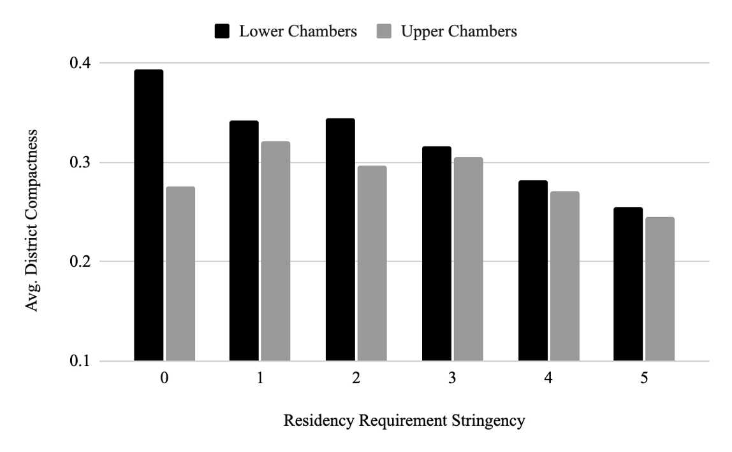

Figure 3: Average Polsby-Popper District Compactness score in lower and upper state legislative chambers based on categorical residency requirement stringency (only includes states which give state legislatures redistricting authority).

Limitation of Electoral Competition
Any additional requirement placed on the act of running for office necessarily brings with it an exclusion of those potential candidates who do not fit that requirement. As a result, it is important to consider which and how many Americans these kinds of requirements might prevent from running for office. Considering and estimating these effects as they pertain to residency requirements is especially crucial given that recent arrivals to states tend to be better-educated and more geographically and economically mobile—qualities that the candidate emergence literature tells us would otherwise land them in a pool of promising potential candidates (Maisel and Stone 1997). Thus, despite the demonstrated benefits of representation deeply rooted in geography, the possible tradeoff in political competition is clear and should not be ignored.
One reason it is important to consider this tradeoff has to do with individual rights of potential or actual candidates. Residency requirements are not without their detractors in this regard, particularly in the legal field. Scholars such as Pitts (2015) have argued that these requirements are fundamentally antidemocratic, and therefore not worth whatever representational benefits they accrue, because they disqualify candidates who might otherwise be the majority’s choice. Others have similarly suggested that these requirements constitute a violation of equal protection in the Constitution, essentially discriminating against those possible candidates who choose or are forced to be geographically mobile (Noonan 1970; Rand 2015). Others still highlight the point that most Americans have (appropriately) celebrated the falling of barriers to the basic franchise for voters. In addition to the weakening of well-known barriers like the poll tax and literacy tests, Mazo (2015) charts the weakening of durational residency requirements for voters in recent decades, opening up the franchise further to geographic newcomers. If Americans are generally skeptical to additional participation barriers when it comes to the franchise, why should we not also err in this direction when it comes to participation in the form of political candidacy? This argument may hold particular weight given how few Americans appear to want or choose to run for office to begin with in the modern era.
More broadly, the potentially detrimental effects of residency requirements matter because of how fundamental healthy political competition is to representational accountability. American elections are regular, well-funded, and attract significant amounts of media attention. But these elections lose much of their meaning and value when their results in many if not most parts of the country are essentially preordained, due in no small part to a too-small pool of viable candidates made even smaller by additional candidacy requirements. Without the enforcement mechanism of competitive elections, elected representatives may feel less beholden to large pockets of their constituency. This representational complacency can also lead to stagnation of political ideas, and the lack of political evolution on the part of the representative. Without the threat of an election challenge to force their hand, elected leaders may not feel the need to update their understanding of issues affecting their constituents as new information and ideas arise in the polity.
As a result, it is crucial as a democratic practice to re-examine whether certain candidacy requirements are worth the trade off an electoral competition. In many cases, these trade-offs are worth it on their face. For instance, age requirements for candidacy are often hotly debated (and should be), particularly among young people. And yet, although opening up political candidacy to (for example) toddlers would significantly widen the pool of potential candidates for office, most Americans would likely agree that this benefit would not be worth the (potentially disastrous) drawbacks involved. In many ways, residency requirements are no different.
There are meaningful and important debates to be had about the stringency of residency requirements; but these debates should not happen without (ideally empirical) evidence about the scope of the sacrifice in competition made in order to ensure locally-rooted representation. The following analysis begins to close this gap by empirically assessing the threat to political competition and candidate emergence. Specifically, I aim to precisely estimate the proportions of specific constituencies who are disqualified from running for office as a result of legal residency requirements in American states. I estimate this primarily in state legislative offices in order to facilitate more variation between candidate and jurisdiction types.
To do this, I have paired the residency requirement legal framework data described earlier in Table 1 with a variety of data from the American Community Survey at both the state and state legislative district levels. First, the ACS asks respondents if they lived in the same house, the same county, or the same state one year ago. From this I calculated the percentage of citizens who lived out-of-state one year ago, and multiplied it by the number of years of state residency required by a state’s laws. This number is what is reflected in the Tier 1 state-by-state estimates in Figure 3 and Table 2. As such, these represent the most conservative estimates for the percentage of the state’s otherwise-eligible citizens who are ineligible for state legislative candidacy.
This ACS question gets us reasonable estimates of which states’ residents are and are not eligible for state legislative office based on each state’s requirement for residency within the state for these offices. It does not, however, account for the additional level of requirement that candidates have residency within their state legislative district for a period of time. County-level estimates are unhelpful here given how wildly counties vary in population size and whether and how much or little they intersect district boundaries. Instead, I use ACS estimates of the percentage of a district’s residents who lived in a different metropolitan or micropolitan statistical area a year ago, on the suspicion that most state legislative districts are small enough such few if any of them contain more than one Metro area, and in most cases only contain one micropolitan area. I multiplied these proportions of citizens by the state requirements as before to produce the estimates of ineligibility represented in the Tier 2 and Tier 3 estimates, with Tier 3 being the least conservative estimates. Detailed descriptions of which groups of migrating residents were included in each Tier can be found in Table 2.

Table 2
State Legislative Candidacy Ineligibility Estimation - Coding Scheme
Tier | Median State Ineligible % | Groups of Residents Include:
1 | 2.9% | Those living in the state who lived in another state a year ago
2 | 5.5% | Tier 1 citizens, plus:  - metro area residents who did not live there a year ago  - micro area residents who lived in a metro area a year ago  - those living in neither type of area who lived in a metro a year ago
3 | 11.2% | Tier 1 and 2 citizens, plus:  - micro area residents who lived in a different micro area a year ago  - micro area residents who lived in a non-metro or micro area a year ago  - metro area residents who lived in a substantially different portion of that area a year ago  - micro area residents who lived in a substantially different portion of that area a year ago
Note: To produce estimates of percent ineligible, totals of all groups above were multiplied by the number of years (or partial years) each state's residency requirements stipulate
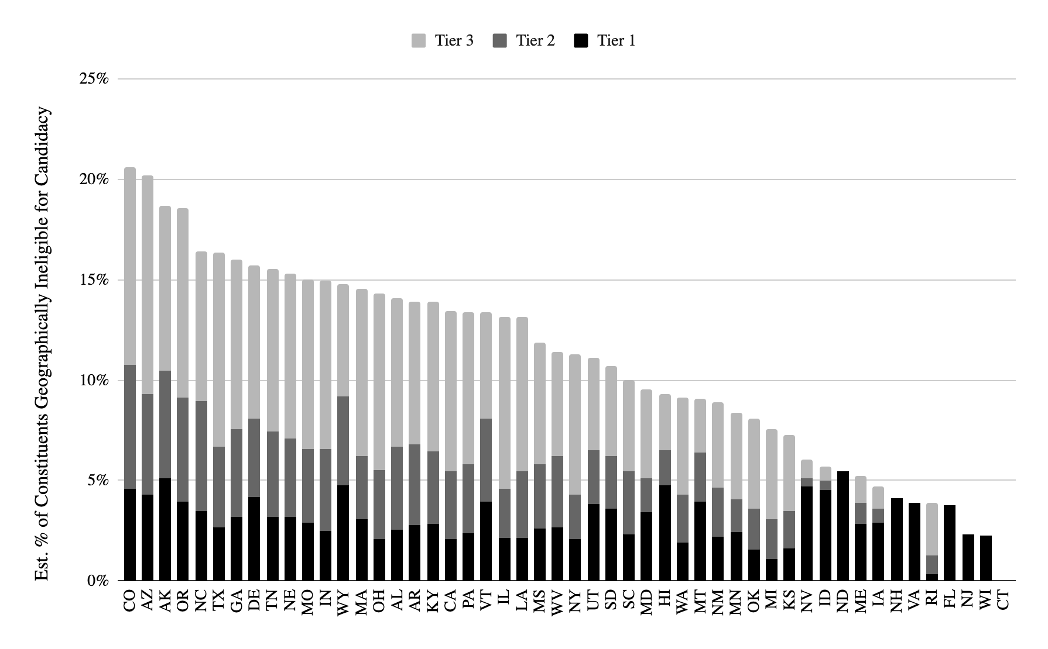
Figure 4: Estimated proportions of state’s residents who are geographically ineligible for candidacy for state legislature. Tiers represent differing analytical assumptions regarding constituents’ geographic mobility, from Tier 1 (most conservative estimate) to Tier 3 (least conservative estimate).

I produced each Tier’s estimates for individual states based on statewide ACS data, the summaries of which can be seen in Figure 4. These numbers paint a picture of residency requirements that, however useful and worthy in their own right, may disqualify as much as a fifth of some state’s residents from serving in their state legislature, particularly in large states in the West and Sun Belt like Colorado, Arizona, North Carolina, and Texas.
The picture is even narrower when applying these estimates at the state legislative district level (N=6,723), as demonstrated by Figure 5, which displays density plots for each Tier, and Figure 6, which maps out lower-house districts based on Tier 3 estimates. Even using the most conservative Tier 1 estimates show a number of districts in which as high as 31% of residents are ineligible for state legislative candidacy; Tiers 2 and 3 show districts with ineligibility estimates as high as 55% and 82%, respectively. These latter districts are no doubt outliers. But the possibility that such considerable proportions of a district’s constituency could fail to even qualify to hold state legislative office should shape future conversations about potential reforms designed to induce candidate recruitment.
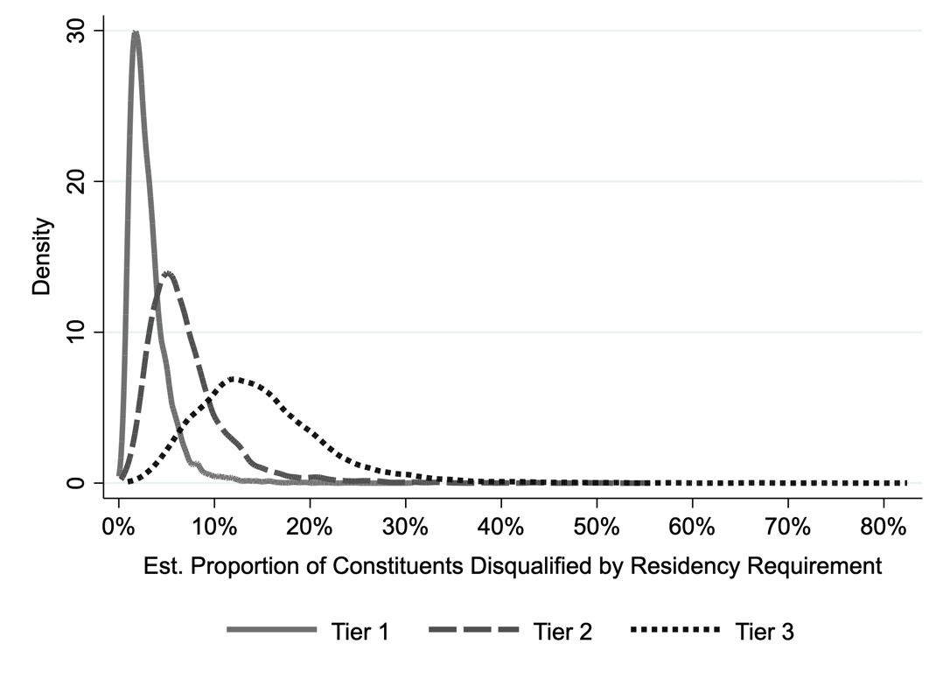

Figure 5: Estimated proportions of constituents who are geographically ineligible for candidacy for state legislature by state legislative district. Tiers represent differing analytical assumptions regarding constituents’ geographic mobility, from Tier 1 (most conservative estimate) to Tier 3 (least conservative estimate).

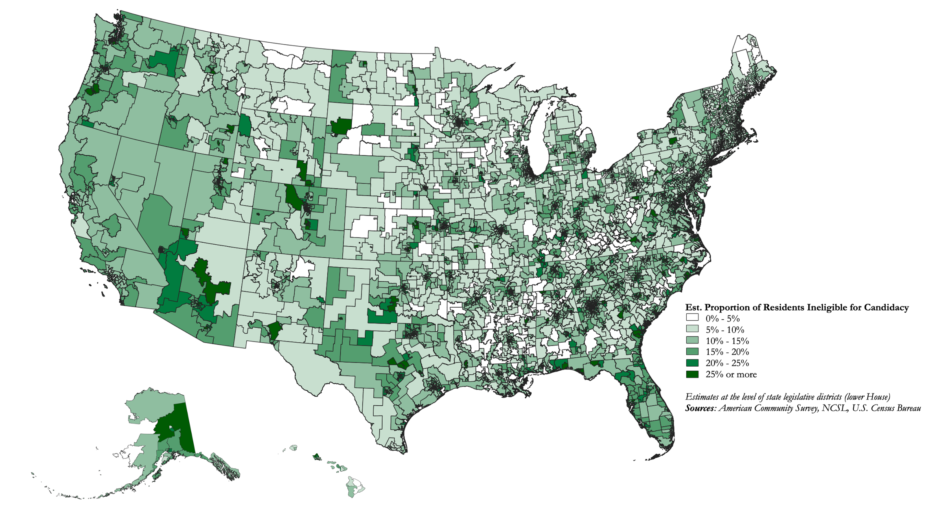
Figure 6: Map of lower-house state legislative districts based on estimated proportions of the district’s residents who are geographically ineligible for candidacy for state legislature. Based on district-level Tier 3 estimates described in Table 2.
Such high levels of ineligibility are particularly important to understand in state legislative races, 41% of which featured candidates who ran unopposed in the general election in 2022. In nearly two dozen state legislative chambers, control for the majority was literally a foregone conclusion before the election because not enough members of one of the two major parties contested a majority of the seats (Kronaizl 2022). Consequently, I use an original dataset drawn from KnowWho, a commercial data firm with key biographical information and previous election results for sitting state legislators as of mid-2018. I merged this data with the above original data on state legislative residency requirements in order to predict the probability of the legislator having run unopposed in their most recent election based on the stringency of the residency requirement. I hypothesize that the stricter the requirement, the higher the probability the state legislator won their race unopposed.
Residency requirements are likely not the primary driver of a lack of electoral competition in state legislatures. For example, more traditional factors like incumbent seniority and the partisan safety of a district are included as covariates to account for whether and how potential challengers consider running for a seat. I also include more recently-theorized factors such as whether a legislator has deep local roots in their home area (Hunt 2022), and utilize Hunt and Rouse’s (2023) state legislator-level Local Roots Index; and institutional factors such as the “flippability” of the chamber as measured by the size (in percentage points) of the current party majority (Burden and Snyder 2021). These and other characteristics of sitting legislators were therefore included as covariates in a logistic regression model that predicts the likelihood that a sitting legislator had run unopposed in their most recent election.
Even after accounting for these other factors, the stringency of a state’s candidate residency requirements appears to have a considerably negative and statistically significant impact on the depth of electoral competition in state legislative elections. As Figure 6 shows, candidates in states with no or few residency requirements for state legislative candidacy are predicted to run unopposed about 12% of the time, while in states with the most stringent requirements, that probability is over 30%. Comparison to other effects can help establish the substantive significance of this increase. For example, this cumulative effect is the same as the one between state legislators who won in districts that were evenly split on a partisan basis in the electorate (based on presidential vote share in the district), and those with 80% support for one party. Put differently, residency requirements have effects on electoral competitiveness that appear to rival that of a district’s partisan balance.
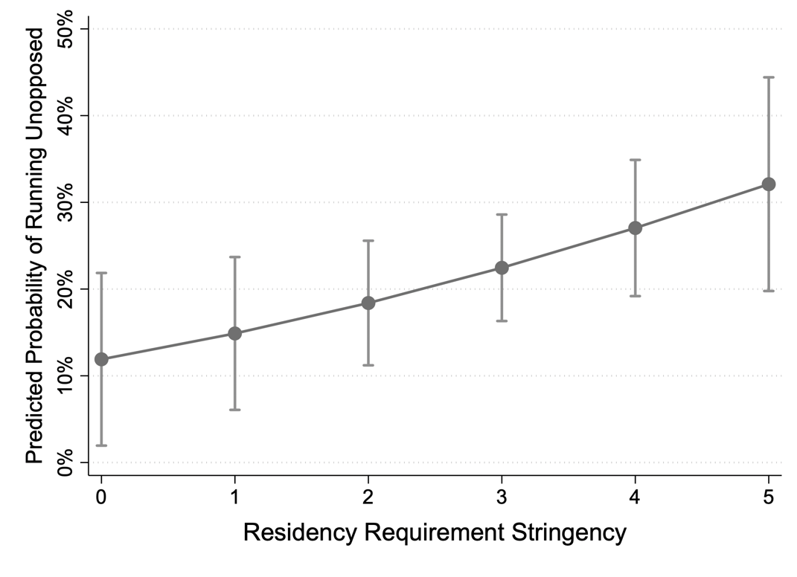

Figure 6: Predicted probability of sitting state legislator having run unopposed in previous general election based on strictness of state’s residency requirements for state legislature. Based on results found in Table A3 in the Appendix.

Discussion
Requirements that officeholders live in or around the jurisdiction they represent—in some cases, for extended periods of time before they serve—is a ubiquitous feature of American political representation that few modern scholars have felt the need to either question or defend. These requirements are taken as granted, not just because they have been a part of the American system since its inception, but because Americans continue to derive deep meaning from the places they live and love. In this paper, I first surveyed the legal and political science literature to lay out the case in favor of these requirements. Just as many Americans value descriptive representation on the basis of race, gender, and party, so too is it clear that they value place-based connections and identities when shared with elected representatives. These connections inspire faith and legitimacy in the political representation voters receive. They also give voters a sense that the local places they care about are not just important, but safe when in the hands of similarly-local representatives who have their best interests at heart because they live there too. These are the kinds of symbolic but crucial representational benefits that candidate residency requirements are instrumental in producing.
Even so, the potential drawbacks of these requirements cannot and should not be ignored. First, I uncovered new evidence that states with strict residency requirements produce districts that are significantly more spatially gerrymandered than states with more flexible requirements, likely due to state legislatures drawing geographically uneven boundaries to please incumbents. I also addressed the potential threat of these requirements to the basic rights of Americans to seek elected office. I demonstrate that residency requirements (particularly durational requirements) narrow the pool of potential candidates to a greater extent than has been previously assumed—by, at the very least, 2-5% in most areas and possibly by 50% or more in others. And although the benefits, consequences and effects analyzed in this paper were primarily applied to the state legislative level, residency requirements can and do affect even higher-profile offices. Statewide offices like governor in many cases have stricter requirements that have even steeper narrowing effects on the candidate pool: Alaska, for example, requires ten years of state residency, a condition that disqualifies nearly a third of Alaska’s citizens from gubernatorial candidacy. The findings in this paper have helped to clarify that whatever benefits residency requirements offer come at a considerable cost to political competition.
In many ways, the debate over residency requirements for political candidates is a legal instantiation of the broader debate over how central a role geography should play in political representation. Many argue, for example, that the nationalization of our politics, culture, and media consumption, coupled with the overwhelming value placed on partisan identity and affiliation for many Americans’ political representation have negated the necessity of geographic boundaries in establishing jurisdictions of representation.
The goal of this study has not been to advocate for or against residency requirements, but rather to explore the reasoning and evidence on either side in ways that have thus far gone understudied and underarticulated. As a policymaking decision, the costs to the redistricting process and political competition I have associated with residency requirements may well be a worthy price to pay for the benefits of locally-rooted, place-specific representation.
Regardless of the face-value merits of these requirements, there is no denying that, for better or worse, we are (and likely will continue to be) a geography-centric polity with institutions that have geography at their bedrock, in areas much more prominent than often-overlooked residency requirements. The Electoral College; federalism; the representational discrepancies between the U.S. House and Senate; the act of voting itself; all require attention and fidelity to elements of nearly unalterable facts of geography like state lines and established levels of government. In a similar way, residency requirements—regardless of the benefits or drawbacks to representation and democracy elucidated in this study—appear unlikely to go by the wayside anytime soon. It seems obvious that Americans in many if not most parts of the country would simply not consent to being represented by someone who refused to even live in their home place. Indeed, in a 2018 poll from Morning Consult, voters were asked to rank preferred character traits for congressional candidates. Democrats, Republicans, and Independents all ranked “always lived in the area” as third or higher, the only such quality all three groups agreed on (Easley 2018). Perhaps geography—unlike party and ideology, which, though powerful, can and do change—is so fundamental and indelible a component of American life that requiring a connection to it is not just reasonable but essential.

References

Amlani, Sharif, and Carlos Algara. 2021. “Partisanship & Nationalization in American Elections: Evidence from Presidential, Senatorial, & Gubernatorial Elections in the U.S. Counties, 1872–2020.” Electoral Studies 73 (October): 102387.
Banducci, Susan A., Todd Donovan, and Jeffrey A. Karp. 2004. “Minority Representation, Empowerment, and Participation.” Journal of Politics 66 (2): 534–56.
Blais, André, Agnieska Dobrzynska, and Indridi H. Indridason. 2005. “To Adopt or Not to Adopt Proportional Representation: The Politics of Institutional Choice.” British Journal of Political Science 35 (1): 182–90.
Bowler, Shaun, Todd Donovan, and Joseph Snipp. 1993. “Local Sources of Information and Voter Choice in State Elections: Microlevel Foundations of the" Friends and Neighbors" Effect.” American Politics Quarterly 21 (4): 473–89.
Burden, Barry C., and Rochelle Snyder. 2021. “Explaining Uncontested Seats in Congress and State Legislatures.” American Politics Research 49 (3): 247–58.
Campbell, Rosie, Philip Cowley, Nick Vivyan, and Markus Wagner. 2019. “Why Friends and Neighbors? Explaining the Electoral Appeal of Local Roots.” The Journal of Politics 81 (3): 937–51.
Cannon’s Precedents of the House of Representatives, Volume 6, § 174.
Childs, Sarah, and Philip Cowley. 2011. “The Politics of Local Presence: Is There a Case for Descriptive Representation?” Political Studies 59 (1): 1–19.
Cramer, Katherine J. 2016. The Politics of Resentment: Rural Consciousness in Wisconsin and the Rise of Scott Walker. University of Chicago Press.
Dovi, Suzanne. 2002. “Preferable Descriptive Representatives: Will Just Any Woman, Black, or Latino Do?” The American Political Science Review 96 (4): 729–43.
Easley, Cameron. 2018. “For Democrats, Minority Women Are the Ideal Candidates.” Morning
Consult, September 13, 2018. https://morningconsult.com/2018/09/13/for-democrats-minority-women-are-the-ideal-candidates/
English, Ashley, Kathryn Pearson, and Dara Z. Strolovitch. 2018. “Who Represents Me? Race, Gender, Partisan Congruence, and Representational Alternatives in a Polarized America.” Political Research Quarterly, October, 1065912918806048.
Fenno, Richard. 1978. Home Style: House Members in Their Districts. Little, Brown.
Gay, Claudine. 2002. “Spirals of Trust? The Effect of Descriptive Representation on the Relationship between Citizens and Their Government.” American Journal of Political Science 46 (4): 717–32.
Gilbert v. State of Alaska. 1974, 526 P.2d 1131. Alaska Supreme Court.
Gimpel, James G., Kimberly A. Karnes, John McTague, and Shanna Pearson-Merkowitz. 2008. “Distance-Decay in the Political Geography of Friends-and-Neighbors Voting.” Political Geography 27 (2): 231–52.
Hopkins, Daniel J. 2018. The Increasingly United States: How and Why American Political Behavior Nationalized. University of Chicago Press.
Hopkins, David A. 2017. Red Fighting Blue: How Geography and Electoral Rules Polarize American Politics. Cambridge University Press.
Hunt, Charles R. 2021a. “Beyond Partisanship: Outperforming the Party Label with Local Roots in Congressional Elections.” Congress & the Presidency 49: 1–30.
———. 2021b. “Expanding Constituency Support Through Shared Local Roots in US House Primaries.” American Politics Research 49 (2): 233–44.
———. 2022a. Home Field Advantage: Roots, Reelection, and Representation in the Modern Congress. University of Michigan Press.
———. 2022b. “Won’t You Be My Senator? Nuanced ‘Friends and Neighbors’ Voting in U.S. Senate Elections, 1968–2018.” Electoral Studies 80 (December): 102540.
Hunt, Charles R., and David Fontana. 2023. “Is Some Politics Still Local? Multimethod Evidence of Voters’ Preference for Local Candidates.” In . Working Paper.
Hunt, Charles R. and Stella M. Rouse. Forthcoming 2023. “Local Candidate Roots and Electoral
Advantages in U.S. State Legislatures. State Politics and Policy Quarterly.
Iglesias, Matthew. 2017. “The Real Fix for Gerrymandering Is Proportional Representation.” Vox. November 6, 2017. https://www.vox.com/policy-and-politics/2017/10/11/16453512/gerrymandering-proportional-representation.
Jacobs, N. F., and B. K. Munis. 2018. “Place-Based Imagery and Voter Evaluations: Experimental Evidence on the Politics of Place.” Political Research Quarterly 72 (2): 263–77.
Johnston, Ron, Mark Wickham-Jones, Charles Pattie, David Cutts, and Hugh Pemberton. 2016. “Friends and Neighbours Voting Revisited: The Geography of Support for Candidates to Lead the UK’s Labour Party.” Political Geography 55: 1–9.
Kaslovsky, Jaclyn and Jesse Crosson. 2023. “Far From Home: Members’ Relationship to the
District and Representation in Congress.” Working paper.
Kronaizl, Douglas. "Uncontested races will result in 23 state legislative chambers where one party is guaranteed to win a simple majority." Ballotpedia News, September 13, 2022. https://news.ballotpedia.org/2022/09/13/uncontested-races-will-result-in-23-state-legislative-chambers-where-one-party-is-guaranteed-to-win-a-simple-majority/
Lahut, Jake. “GOP Senate candidate Mehmet Oz misspelled the name of his Pennsylvania
address in official campaign form.” BusinessInsider, June 13, 2022.
https://www.businessinsider.com/oz-pennsylvania-residence-spelling-campaign-form-2022-6
Madison, James. 1787. Notes on the Debates in the Federal Convention. August 8, 1787. Yale
University Law School, the Avalon Project.
https://avalon.law.yale.edu/18th_century/debates_808.asp#1
Maisel, L. Sandy, and Walter J. Stone. 1997. “Determinants of Candidate Emergence in U. S. House Elections: An Exploratory Study.” Legislative Studies Quarterly 22 (1): 79–96.
Mansbridge, Jane. 1999. “Should Blacks Represent Blacks and Women Represent Women? A Contingent" Yes".” The Journal of Politics 61 (3): 628–57.
Maskell, Jack. 2015. “Qualifications of Members of Congress.” Congressional Research Service
Report 7-5700. https://sgp.fas.org/crs/misc/R41946.pdf
Mazo, Eugene D. 2015. “Residency and Democracy: Durational Residency Requirements from the Framers to the Present.” Fla. St. UL Rev. 43: 611.
Meredith, Marc. 2013. “Exploiting Friends-and-Neighbors to Estimate Coattail Effects.” The American Political Science Review 107 (4): 742–65.
Monroe, Burt L. 1995. “Fully Proportional Representation.” The American Political Science Review 89 (4): 925–40.
Moskowitz, Daniel J. 2021. “Local News, Information, and the Nationalization of U.S. Elections.” The American Political Science Review 115 (1): 114–29.
Munis, B. Kal. 2021. “Place, Candidate Roots, and Voter Preferences in an Age of Partisan Polarization: Observational and Experimental Evidence.” Political Geography 85 (March): 102345.
Noonan, David J. 1970. “The Durational Residency Requirement as a Qualification for Candidates for State Legislature: A Violation of Equal Protection.” Syracuse Law Review 22: 1079.
Pitts, Michael J. 2015. “Against Residency Requirements.” The University of Chicago Legal Forum, 341.
Rand, Justin Louis. 2015. “Carpetbagger Battle Cry: Scrutinizing Durational Residency Requirements for State and Local Offices.” Rutgers JL & Pub. Pol’y 13: 242.
Rosenberg, Jonas Hultin, and Johan Wejryd. 2022. “Attitudes toward Competing Voting-Right
Requirements: Evidence from a Conjoint Experiment.” Electoral Studies 77: 102470.
Sajuria, J. E., and S. Collignon. 2018. “Local Means Local, Does It? Regional Identification and Preferences for Local Candidates.” Electoral Studies.
Schulte-Cloos, Julia, and Paul C. Bauer. 2021. “Local Candidates, Place-Based Identities, and Electoral Success.” Political Behavior, May. https://doi.org/10.1007/s11109-021-09712-y.
Swers, Michele L. 2002. The Difference Women Make: The Policy Impact of Women in Congress. University of Chicago Press.
Tatalovich, Raymond. 1975. “‘ Friends and Neighbors’ Voting: Mississippi, 1943-73.” The Journal of Politics 37 (3): 807–14.
Wolak, Jennifer, and Eric Gonzalez Juenke. 2021. “Descriptive Representation and Political Knowledge.” Politics, Groups, and Identities 9 (1): 129–50.

See Appendix Tables A1 and A2 for state-by-state summaries of residency requirements for state legislative and gubernatorial officeholding, respectively.
A handful of states require establishment of residency “at time of filing” for candidacy. In some cases this means a residency requirement of 7-8 months in advance of the November election; in others, it means only 4-6 months. These states were each categorized within the appropriate bins listed in Figure 1. The list of states with this requirement, their filing deadlines for the 2022 elections, and the calculated time in months prior to the November election, can be found in Appendix Table A4.
Mason’s quotation brings to mind modern politicians such as former Sen. Scott Brown (R) who, after losing re-election in Massachusetts in 2012, ran again in 2014, this time in neighboring New Hampshire. Brown also last that bid to incumbent Sen. Jeanne Shaheen (D).
However, Madison’s concern is not borne out in modern data. In addition to the findings below on electoral competition, state legislative data indicate no particular correlation between the strictness of a state’s residency requirement and prevalence in their legislators of typical markers of candidate quality like college education, postgraduate education, and prior political experience.
Others, like Mazo (2016), have rebutted this line of argument using similar logic: if durational residency requirements are enacted by democratically-elected legislatures, then “their existence reflects a democratic judgment made by the people in the first place.”
This includes diluting this percentage when a state’s requirement is less than a year; for example, if the requirement is six months, I multiplied the figure by 0.5. This, of course, assumes uniform distribution of migration across the span of a year in a particular area; although migration does not likely occur in this fashion in reality, year-level estimates are the most granular form of this data that is currently available and able to be matched reasonably to state legislative district boundaries.
As a result, the Tier 2 and Tier 3 estimates likely remain conservative for smaller-geography, higher-population districts encompassed entirely within a single major metropolitan area.
Earlier sections argued that geographic residency requirements are in part an effort to produce deeply rooted candidates to begin with. Indeed, I do find some descriptive correlation between the stringency of residency requirements, and the depth of winning candidates local roots based on Hunt and Rouse’s (2023) LRI. However, the correlation is statistically modest (Pearson correlation score = .147). In addition, running models that excluded either the LRI or the residency requirement stringency variables produced coefficients that were not substantively or statistically different from those in the combined model used in the main text (see Appendix Table A5).
A full list of states, their gubernatorial residency requirements, and estimated disqualification rates can be found in Appendix Table A2.

